Date: 22nd May, 2026

Ref:

REQUEST FOR TENDERS

Ebenezer Thomas Primary School Classroom Container Retrofitting

PART A – GENERAL PROVISIONS

- Introduction

  - The Government of the Virgin Islands (GoVI) acting through the Ministry of Education, Youth Affairs & Sports (MEYAS) invites you to submit a tender for the Ebenezer Thomas Primary School Classroom Container Retrofitting located in Sea Cow’s Bay, TORTOLA, Virgin Islands (hereinafter referred to as the “Works”).

  - The Works are intended to support the up-keep and necessary maintenance of the school.

  - As a part of this procurement process, you are required to visit the site in good time to allow you assess the existing conditions, the requirements of the Works, and determine the equipment, materials, and labour required to complete the Works.

  - Section 5 of this Request for Tenders (RFT) provides the general requirements for the Works from which a tender should be prepared.

  - Your company has been determined to be qualified and have the relevant experience to complete the Works. Therefore, the price tender will be the only considerations in assessment of tenders.

- Submission of Tenders

  - The Tenderer should read these instructions carefully before completing the tender documentation. The Tender must include each of the following documents identified below, fully completed by the Tenderer together with any supporting literature required by the relevant document. The documents marked ‘Appendix’ are provided as appendices to this document.

- Form of Tender (Appendix A)
- Tender Price (Appendix B)
- Extended Scope of Works (Appendix C)

  - Failure to comply with any of the instructions concerning completion and submission of these documents may render (at GoVI’s absolute discretion) the Tender non-compliant.

  - The Form of Contract, if required, is attached at Appendix D. It identifies the proposed terms and conditions, and the documents that shall be incorporated within any resulting Contract.

  - Tenders must be submitted to the Permanent Secretary, Ministry of Education, Youth Affairs & Sports at the following address:

Permanent Secretary
Ministry of Education, Youth Affairs & Sports
2nd Floor E.A Creque Building
Main Street
Road Town, Tortola
BRITISH VIRGIN ISLANDS

  - Tenderers must submit one (1) original and one (1) copy of the complete tender package, including appendices and supporting literature in one envelope clearly marked with the reference “Ebenezer Thomas Primary School Classroom Container Retrofitting”. The original tender and copies must be clearly marked accordingly, and all information must be legible.

  - Tenders must be submitted no later than 10th June, 2026 at 12:00 PM local time. Tenders received after this date and time will be rejected and not be considered.

- Site Visit

  - Tenderers are required to attend a site visit on Thursday, 28th May, 2026 at 11:00 a.m. to assess the existing conditions, the requirements of the Works, and determine the equipment and labour required to complete the Works.

- General

  - GoVI reserves the right, and at its own discretion, to accept or reject any Tender, and to annul the process and reject all Tenders, at any time prior to award of contract without assigning reason, and without incurring any liability to the affected prospective Tenderer(s).

  - GoVI will not defray any costs incurred by any Tenderer in the preparation of Tenders.

PART B – EMPLOYER’S REQUIREMENTS

- Tender Specifications

  - The successful tenderer (the “Contractor”) will be required to complete Ebenezer Thomas Primary School Classroom Container Retrofitting (see extended outline at Appendix C):

- Time of Engagement

  - The duration of this engagement will be for a period of two (2) months.

- Evaluation

  - Price, experience, methodology, timeline schedule, and submission of ALL good standings (Trade License, Inland Revenue, SSB and NHI) are the factors that will be considered in this evaluation. Therefore, the tenderer submitting the tender with all the items listed in 7.1 will be selected as the recommended tenderer and invited to negotiate a contract to complete the Works.

- Disclaimers

  - The Tender process is governed by and construed in accordance with the Laws of the Virgin Islands.

  - All material issued in connection with this RFT shall remain the property of GOVI and shall be used only for the purpose of this competitive tendering exercise.

  - GOVI shall not be committed to any course of action as a result of:

    - Issuing an RFT;

    - Communicating with a Tenderer or a Tenderer’s representatives or agents in respect of this procurement; or

    - Any other communication between GOVI and any other party.

  - Tenderers shall accept and acknowledge that by issuing this RFT, GOVI shall not be bound to accept any Tender and reserves the right not to award the Contract for some or all of the Works for which Tenders are invited.

  - No information contained in this RFT, or in any communication made between GOVI and any Tenderer in connection with this RFT, shall be relied upon as constituting a Contract, agreement, or representation that any Contract shall be offered as a result of this competitive tendering exercise. GOVI reserves the right, to change without notice the basis of, or the procedures for, the competitive tendering exercise or to terminate the competitive tendering exercise at any time.

  - Tenderers are solely responsible for the costs and expenses incurred in connection with the preparation and submission of their Tender and all other stages of the selection and evaluation process. Under no circumstances will GOVI or any of their advisers, be liable for any costs or expenses borne by Tenderers, sub-contractors, suppliers, or advisers in this competitive tendering exercise.

  - GOVI reserves the right to reject Tenders which are not submitted in accordance with the instructions given, including but not limited to where a Tenderer:

    - Submits it Tender after the deadline for tender submissions;

    - Provides a Tender that is incomplete and fails to provide any of the required information;

  - GOVI reserves the right to reject any or all Tenders, to stop the competitive tendering exercise and not award the Contract (in whole or in part) at any time without any liability on its part. Nothing in this competitive tendering exercise is intended to form any express or implied contractual relationship between the parties unless and until the Contract is executed by both parties.

  - Where there is any indication that a conflict of interest exists or may arise then it shall be the responsibility of the Tenderer to inform GOVI detailing the conflict in writing. GOVI will be a final arbiter on cases of potential conflicts of interest. A failure to notify GOVI of any potential conflict of interest will invalidate any oral or written agreement.

  - Participation in the tendering process shall be treated by GOVI as acceptance by the Tenderer of all the terms and conditions contained in this RFT (or any other statement that may be issued by GOVI to Tenderers from time to time) relating to the conduct of this competitive tendering exercise (including any subsequent award of a Contract).

  - Tenderers must be explicit and comprehensive in their responses to this RFT as this will be the single source of information on which responses will be evaluated save for any further information or advice sought by GOVI in accordance with the Clarification of Tenders paragraph above. Tenderers are advised neither to make any assumptions about their past or current supplier/contractor relationships with GOVI nor to assume that such prior business relationships will be taken into account in the evaluation procedure.

  - The RFT is issued on the basis that nothing contained in it shall constitute an inducement or incentive nor shall have in any other way persuaded a Tenderer to submit a Tender or enter into the Contract or any other contractual agreement.

  - GOVI relies on a Tenderer's own analysis and review of information provided. Consequently, Tenderers are solely responsible for obtaining the information which they consider is necessary in order to make decisions regarding the content of their Tenders and to undertake any investigations they consider necessary in order to verify any information provided to them during the competitive tendering exercise.

- Corrupt and Fraudulent Practices

  - GOVI requires that Tenderers, Suppliers, Contractors, and Consultants under GOVI-funded contracts, observe the highest standard of ethics during the procurement and execution of such contracts. In pursuit of this policy, GOVI:

    - Defines, for the purposes of this provision, the terms set forth below as follows:

      - “Corrupt practice” means the offering, giving, receiving, or soliciting, directly or indirectly, of anything of value to influence the action of a public official in the procurement process or in contract execution.

      - “Fraudulent practice” means a misrepresentation of facts in order to influence a procurement process or the execution of a contract.

      - “Collusive practice” means a scheme or arrangement between two or more Tenderers, with or without the knowledge of the Recipient, designed to establish Tender prices at artificial, non-competitive levels; and

      - “Coercive practice” means harming or threatening to harm, directly or indirectly, persons or their property to influence their participation in the procurement process or affect the execution of a contract.

    - Will reject a proposal for award if it determines that the Tenderer recommended for award has, directly or through an agent, engaged in corrupt, fraudulent, collusive or coercive practices in competing for the Contract; and

    - May sanction a firm or individual, including declaring them ineligible, either indefinitely or for a stated period of time, to be awarded a GOVI-financed contract if it at any time determines that they have, directly or through an agent, engage in corrupt, fraudulent, collusive, or coercive practices in competing for, or in executing, a GOVI-financed contract.

- Tender Validity

  - Tenders should remain open for acceptance for a period of 30 days from date of the Tender closing date.

End of Section

APPENDIX A

FORM OF TENDER

Permanent Secretary
Ministry of Education, Youth Affairs & Sports
2nd Floor, E.A. Creque Building
Main Street
Road Town, Tortola
British Virgin Islands

TENDER

For: Ebenezer Thomas Primary School Classroom Container Retrofitting

To: Permanent Secretary, Ministry of Education, Youth Affairs & Sports

1. Based upon the requirements of this Request for Tender, the undersigned proposes to complete the Works as indicated in our tender submission and in accordance with the Tender Documents for the sum of (US$),

US$__________________________________________________ (amount in figures)

__________________________________________________________________________

_______________________________________________________ (amount in words)

payable by the Government of the Virgin Islands.

2. The undersigned engagement will be for a period of two (2) months.

3. We agree that the proper law of the Contract shall be the Laws of the Virgin Islands.

4. We agree that these tender documents shall comprise the sole binding documentation applicable to this tender or to the contract.

5. We agree that all information supplied by the Employer to the Tenderer will be treated in confidence and not disclosed to third parties except insofar as this is necessary to obtain sureties or tenders for the purpose of submitting the tender. All information supplied by the Tenderer to the Employer will similarly be treated in confidence, except, that references may be sought from banks, existing or past clients, or other referees submitted by the Tenderer.

6. We accept full responsibility for the accuracy of all prices provided in this tender and agree that these prices include full provision for any increases in the costs for whatsoever reason over the period of time from submission of tender to completion of the project and settlement of the final account.

7. We accept that any and all omissions or errors in pricing are our responsibility and agree that should any errors in arithmetic be discovered in the Tender submitted by us during consideration of this offer, these errors will be corrected by giving us an opportunity of either confirming our offer or amending it to correct such errors.

8. If this offer is accepted and subject to and in accordance with paragraphs 2, 3, 4, 5, 6 and 7 above and the terms and conditions contained referred to in the Tender Documents, we undertake to provide the required services as in accordance with the contract.

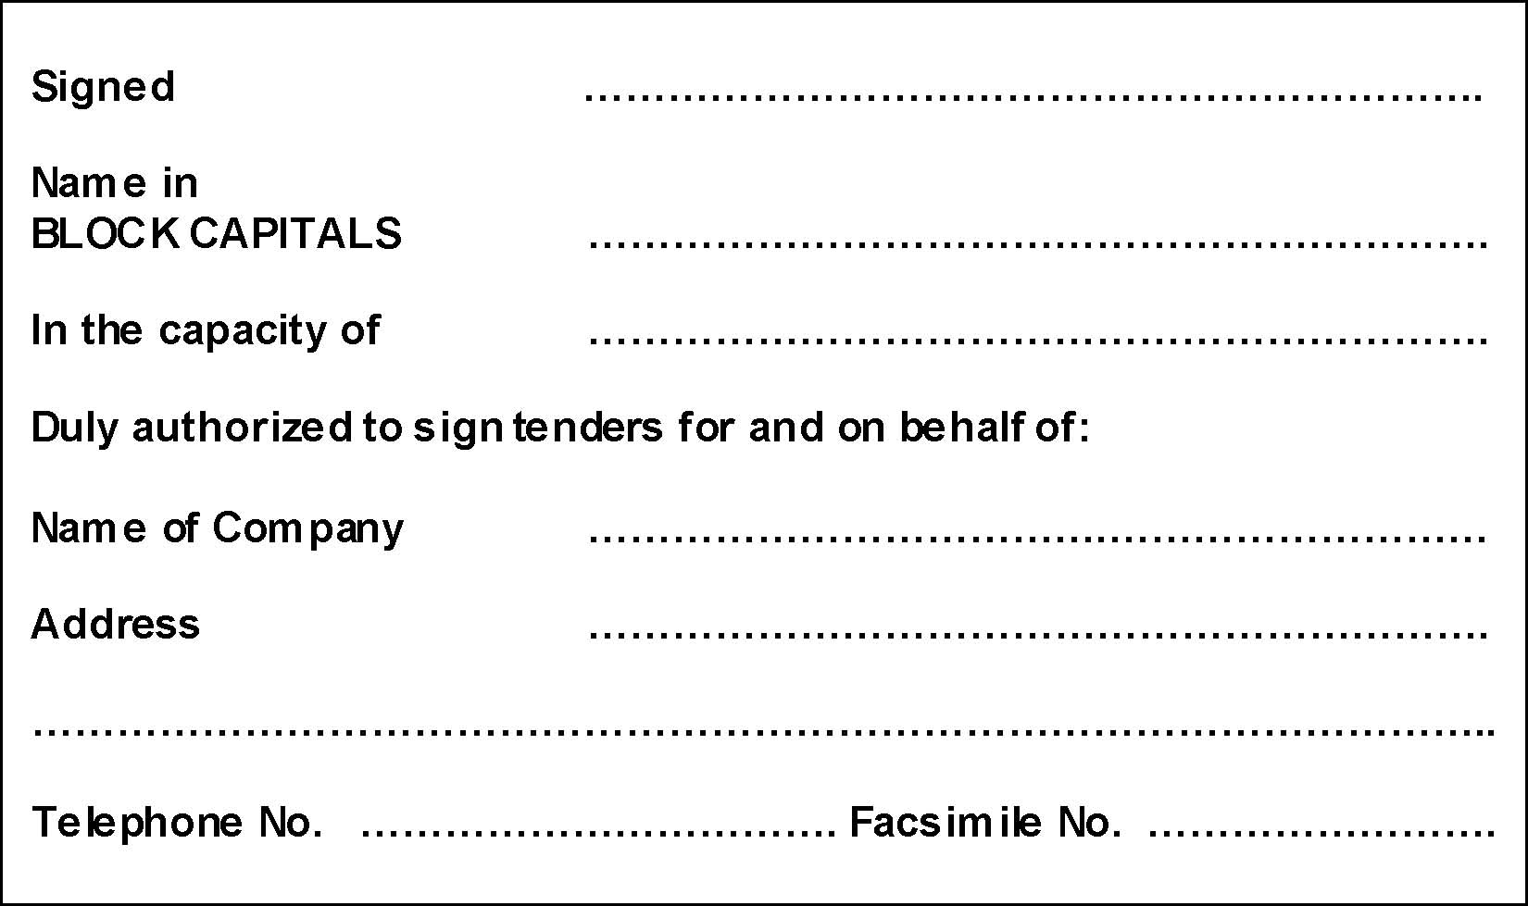

APPENDIX B

TENDER PRICE

Item | Description | Price
1 | To complete Ebenezer Thomas Primary School Classroom Container Retrofitting (Please attach cost breakdown)
 | Total Tender Price in Accordance with Section 5 of the RFT for 2026

APPENDIX C

Extended Scope of Works

Project Description

The works consist of the supply, installation, retrofitting, and commissioning of one (1) 40-foot expandable container to be used as a two-classroom facility. The container shall be modified to include electrical systems, lighting, air-conditioning provisions, partitioning, roofing, walkway covering, and interior framing works.

Container Description

- Provide electrical and interior retrofitting for one (1) 40-foot expandable modern container.
- Container interior shall be divided into two (2) separate classrooms by constructing a full-height partition wall at the center.
- Partition framing shall be constructed using treated lumber framing members with plywood or approved wall sheathing finish.

Structural and Roofing Works

- Supply and install a complete roof structure above the container to provide additional weather protection and reduce heat transfer.
- Roof framing shall be constructed using treated lumber framing members securely anchored to the container structure.
- Supply and install ice and water shield membrane over the roof decking prior to installation of roof sheeting.
- Supply and install galvanized roof sheeting over the ice and water shield membrane.
- All roof fasteners, flashing, ridge caps, and accessories shall be galvanized and weather resistant.
- Roof shall be designed with adequate pitch and overhangs to allow proper drainage of rainwater away from the container.
- Supply and install gutters and downspouts where required.
- Provide a covered walkway canopy extending from the container entrance area as directed on site.
- Walkway roof framing shall be treated lumber with ice and water shield membrane and galvanized roof sheeting to match the main roof system.

Electrical Distribution

- Supply and install one (1) main electrical panel inside the container.
- Panel shall be prewired and installed in accordance with NEC standards.
- Panel shall include properly sized main breaker and branch breakers for lighting, receptacles, and air conditioning units.
- Provide complete grounding and bonding system for the container structure and electrical installation.

Receptacle Installation

- Install 2 duplex electrical outlets on all walls in both rooms.
- Receptacles shall be spaced to meet NEC code requirements for general-use outlets.
- All receptacles shall be grounded and installed at standard mounting height unless otherwise directed.
- Provide dedicated outlets for air-conditioning units and equipment as required.

Lighting Installation

- Supply and install LED 5000K day light ceiling light fixtures in both rooms.
- Lighting layout shall provide uniform illumination suitable for classroom use.
- Lights shall be controlled by wall-mounted switches located near each room entrance.
- All fixtures shall be energy efficient and securely mounted.

Two (2) – 12,000 BTU Air-Conditioning Installation

- Supply electrical connections for one air conditioning unit per room (two total).
- Each AC unit shall have:
  - Dedicated circuit breaker
  - Local disconnect if required
  - Wiring sized per manufacturer specifications
  - Contractor shall provide all conduits, fittings, supports, and accessories necessary for complete installation.

Interior Framing and Finishing

- Construct interior partition walls using treated wood framing.
- Install plywood or approved wall finish materials on both sides of partition walls.
- Provide framing support as necessary for doors, electrical fixtures, and mounted equipment.
- Finish all exposed edges and joints neatly.

Sheetrock Storage Rack Wall

- Supply and install a sheetrock/storage rack wall system as directed on site.
- Wall framing shall be constructed using treated lumber framing members.
- Installation shall be securely fastened and capable of supporting intended storage loads.

Wiring and General Requirements

- All wiring shall be installed in conduit or approved raceway systems.
- All electrical equipment and materials shall be UL listed and suitable for the intended environment.
- Label all circuits clearly in the panel directory.
- All penetrations through container walls and roof shall be properly sealed and weatherproofed.
- Installation shall comply with:
  - National Electrical Code (NEC)
  - Local building and electrical regulations

Contractor Responsibilities

- Contractor shall provide all labor, supervision, tools, equipment, transportation, and materials necessary to complete the works.
- Contractor shall verify all site dimensions and field conditions prior to commencement of work.
- Contractor shall maintain a safe and clean work environment throughout the project duration.
- Any damaged surfaces resulting from the works shall be repaired to original condition.

Completion Requirements

- Systems shall be fully tested and commissioned upon completion.
- Contractor shall demonstrate proper operation of lighting, receptacles, panel systems, and air conditioning connections.
- All debris and unused materials shall be removed from site upon completion of works.

